**Improvements and Observations:**

**Observation:** The error message shown for the filter has been overlooked for the typos.

**Environment:** Production

**Device:** All

**Severity:** Medium

**Steps to reproduce:**

**Given** Im on the customise trouser page  
**When** I select the color as "Black"  
**And** design as "Stripes"  
**Then** I should see the correct Error message

**Expected Result:**

Message should be displayed as,

We’re sorry, no fabrics were found for your selection. Try new combinations.

**Actual Result:**

The error message is scrambled.

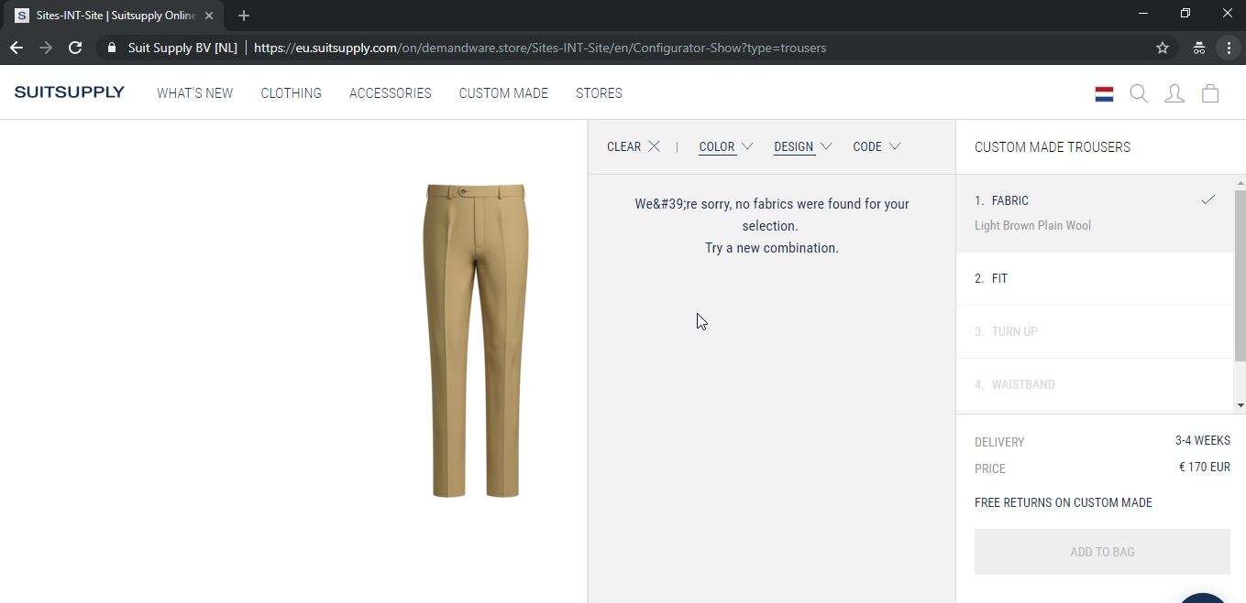

**Improvement:**

The website version of customise trouser model lacks very integrative mood of design due to the loading of the image every time takes longer time.

I see the image is downloaded every time when I change the selection and a call is made to fetch the images. The following options could improve this performance issue.

1. Locally cache the pictures of the previous selection
2. Use cloud front for the images and load the images from the cache.